Balanced or unbalanced?

Look at each pair of forces.
Are they balanced or unbalanced? Put a ring round the right answer.

1 | 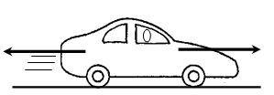 | Balanced  or  Unbalanced
2 | 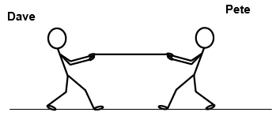 | Balanced  or  Unbalanced
3 | 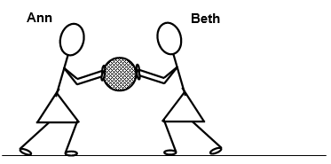 | Balanced  or  Unbalanced
4 | 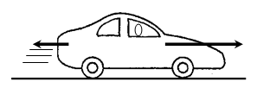 | Balanced  or  Unbalanced
5 | 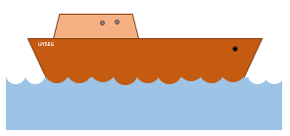 | Balanced  or  Unbalanced

Physics > Big idea PFM: Forces and motion > Topic PFM1: Forces > Key concept PFM1.3: Balanced and unbalanced forces
Diagnostic question
Balanced or unbalanced?

Overview
Learning focus: | The resultant force is the sum of the forces acting on the object, taking into account their direction. If there is no resultant force, the forces are balanced. Unbalanced forces change the speed, direction and/or shape of an object.
Observable learning outcome: | - Identify pairs of forces that are balanced or unbalanced.
Question type: | Diagnostic, simple multiple choice
Key words: | Force, balanced, unbalanced

What does the research say?
When Erikson and Hobbs (1978) investigated students’ ideas about two forces acting on the same object they found that, in a study of 32 Canadian students aged 6-14, the students appeared to think of several forces engaged in a struggle, with the bigger force dominating the weaker one. Osborne (1985) found similar thinking amongst students in New Zealand.
Equilibrium was seen by ten students, in a group of 26, as an end to this struggle after which the forces ceased to act. In fact, both forces continue to act, but there is ‘not force left over to make things change’.
This question introduces the terms balanced and unbalanced to describe pairs of forces that are acting on an object in the same straight line. This is the simplest way to combine forces and is a step towards students being able to analyse more complex groups of forces acting on an object.
Ways to use this question
Students should complete the question individually. This could be a pencil and paper exercise, or you could use an electronic ‘voting system’ or mini white boards and the PowerPoint presentation.
The answers to the question will show you whether students understood the concept sufficiently well to apply it correctly.
If there is a range of answers, you may choose to respond through structured class discussion. Ask one student to explain why they gave the answer they did; ask another student to explain why they agree with them; ask another to explain why they disagree, and so on. It can be helpful to ask ‘is there any force left over?’, ‘which way is the force left over pushing/pulling?’ This sort of discussion gives students the opportunity to explore their thinking and for you to really understand their learning needs.
Differentiation
You may choose to read the questions to the class, so that everyone can focus on the science. In some situations it may be more appropriate for a teaching assistant to read for one or two students.
Expected answers
- Balanced 2. Balanced 3. Unbalanced 4. Unbalanced 5. Balanced
How to respond - what next?
This is question is quite simple in that students identify whether opposing forces are the same size (balanced) or not (unbalanced).
If students have difficulty in identifying balanced and unbalanced forces they may not be clear about the definitions of balanced and unbalanced. It may be helpful to rehearse using the correct terms with these examples and to give the students further ones to practise.
You might choose to challenge students to identified balanced and unbalanced forces from pictures of videos, where forces are not labelled.
The size of the ‘resultant’ force (the force left over) is considered in the diagnostic questions: ‘Resultant force’ and ‘How much is left over?’
The effects of balanced and unbalanced forces are considered in the diagnostic questions: ‘What happens next?’ and ‘What changes?’
Acknowledgments
Developed by Peter Fairhurst (UYSEG).
Images: EPSE and UYSEG
References
Erickson, G. and Hobbs, E. (1978) ‘The developmental study of student beliefs about force concepts’, Paper presented to the 1978 Annual Convention of the Canadian Society for the Study of Education. 2 June, London, Ontario, Canada.
Osborne, R. (1985) ‘Building on children’s intuitive ideas’, in Osborne, R. and Freyberg, P., Learning in Science, Heinemann, Aukland, New Zealand.

